AI Math Tutor

- PROJECT DOCUMENTATION

COLLEGE CODE : 0110
COLLEGE : Dharmamurthi Rao Bahadur Calavala Cunnan Chetty's Hindu College

Team ID : SWTID-2026-9761
Team Size : 4

Team Leader : SANTHOSH V (09FB6F9C8CB3BC9826240BA8BA32931C)
Team member : VIGNESH J (4418576939024ACBB274D5252CD7CEA9)
Team member : VISWANATHAN I (84065F747C4D68A8BBB4746BA00A4E0A)
Team member : GOKUL M (928CFA583733DA1B37F48B8963FE10B6)

ABSTRACT

AI Math Tutor is an intelligent educational platform designed to help students solve algebra equations from images.
Students often struggle with handwritten symbols, equation interpretation, and step-by-step reasoning.
This system allows users to upload an image of an algebra problem and automatically converts it into LaTeX format using OCR and AI models.
The extracted equation is solved using symbolic mathematics and the platform generates step-by-step explanations.
It also highlights common algebra mistakes, improving conceptual understanding and learning outcomes.
AI Math Tutor is an intelligent educational platform designed to help students solve algebra equations from images.
Students often struggle with handwritten symbols, equation interpretation, and step-by-step reasoning.
This system allows users to upload an image of an algebra problem and automatically converts it into LaTeX format using OCR and AI models.
The extracted equation is solved using symbolic mathematics and the platform generates step-by-step explanations.
It also highlights common algebra mistakes, improving conceptual understanding and learning outcomes.
AI Math Tutor is an intelligent educational platform designed to help students solve algebra equations from images.
Students often struggle with handwritten symbols, equation interpretation, and step-by-step reasoning.
This system allows users to upload an image of an algebra problem and automatically converts it into LaTeX format using OCR and AI models.
The extracted equation is solved using symbolic mathematics and the platform generates step-by-step explanations.
It also highlights common algebra mistakes, improving conceptual understanding and learning outcomes.
AI Math Tutor is an intelligent educational platform designed to help students solve algebra equations from images.
Students often struggle with handwritten symbols, equation interpretation, and step-by-step reasoning.
This system allows users to upload an image of an algebra problem and automatically converts it into LaTeX format using OCR and AI models.
The extracted equation is solved using symbolic mathematics and the platform generates step-by-step explanations.
It also highlights common algebra mistakes, improving conceptual understanding and learning outcomes.

INTRODUCTION

Mathematics education increasingly benefits from artificial intelligence technologies.
Students frequently make mistakes while solving algebra problems due to sign errors, incorrect transposition, or arithmetic mistakes.
AI Math Tutor aims to reduce these issues by combining image recognition, OCR, and symbolic mathematics.
The platform interprets algebra problems from images and provides logical explanations for each step of the solution.
Mathematics education increasingly benefits from artificial intelligence technologies.
Students frequently make mistakes while solving algebra problems due to sign errors, incorrect transposition, or arithmetic mistakes.
AI Math Tutor aims to reduce these issues by combining image recognition, OCR, and symbolic mathematics.
The platform interprets algebra problems from images and provides logical explanations for each step of the solution.
Mathematics education increasingly benefits from artificial intelligence technologies.
Students frequently make mistakes while solving algebra problems due to sign errors, incorrect transposition, or arithmetic mistakes.
AI Math Tutor aims to reduce these issues by combining image recognition, OCR, and symbolic mathematics.
The platform interprets algebra problems from images and provides logical explanations for each step of the solution.
Mathematics education increasingly benefits from artificial intelligence technologies.
Students frequently make mistakes while solving algebra problems due to sign errors, incorrect transposition, or arithmetic mistakes.
AI Math Tutor aims to reduce these issues by combining image recognition, OCR, and symbolic mathematics.
The platform interprets algebra problems from images and provides logical explanations for each step of the solution.

OBJECTIVES

1. Recognize algebra equations from images.
2. Convert extracted text into LaTeX format.
3. Solve equations using symbolic computation.
4. Generate step-by-step explanations.
5. Detect common algebra mistakes.
6. Provide an interactive learning interface.
1. Recognize algebra equations from images.
2. Convert extracted text into LaTeX format.
3. Solve equations using symbolic computation.
4. Generate step-by-step explanations.
5. Detect common algebra mistakes.
6. Provide an interactive learning interface.
1. Recognize algebra equations from images.
2. Convert extracted text into LaTeX format.
3. Solve equations using symbolic computation.
4. Generate step-by-step explanations.
5. Detect common algebra mistakes.
6. Provide an interactive learning interface.
1. Recognize algebra equations from images.
2. Convert extracted text into LaTeX format.
3. Solve equations using symbolic computation.
4. Generate step-by-step explanations.
5. Detect common algebra mistakes.
6. Provide an interactive learning interface.

SYSTEM ARCHITECTURE

The following diagram illustrates the architecture of the AI Math Tutor platform.
The following diagram illustrates the architecture of the AI Math Tutor platform.
The following diagram illustrates the architecture of the AI Math Tutor platform.
The following diagram illustrates the architecture of the AI Math Tutor platform.

SYSTEM WORKFLOW

The workflow demonstrates how an image is processed and converted into a mathematical solution.
The workflow demonstrates how an image is processed and converted into a mathematical solution.
The workflow demonstrates how an image is processed and converted into a mathematical solution.
The workflow demonstrates how an image is processed and converted into a mathematical solution.

USER INTERFACE

The Streamlit interface allows students to upload images and view solutions interactively.
The Streamlit interface allows students to upload images and view solutions interactively.
The Streamlit interface allows students to upload images and view solutions interactively.
The Streamlit interface allows students to upload images and view solutions interactively.

EQUATION SOLVING EXAMPLE

Example of step-by-step algebra solving generated by the system.
Example of step-by-step algebra solving generated by the system.
Example of step-by-step algebra solving generated by the system.
Example of step-by-step algebra solving generated by the system.

MISTAKE DETECTION

The system analyzes solving steps and highlights common algebra mistakes.
The system analyzes solving steps and highlights common algebra mistakes.
The system analyzes solving steps and highlights common algebra mistakes.
The system analyzes solving steps and highlights common algebra mistakes.

TECHNOLOGIES USED

Python – Programming language
Streamlit – Web interface
OpenCV – Image preprocessing
EasyOCR/Tesseract – Text extraction
Gemini Vision – Image understanding
SymPy – Algebra solving
MathJax – Mathematical rendering
Python – Programming language
Streamlit – Web interface
OpenCV – Image preprocessing
EasyOCR/Tesseract – Text extraction
Gemini Vision – Image understanding
SymPy – Algebra solving
MathJax – Mathematical rendering
Python – Programming language
Streamlit – Web interface
OpenCV – Image preprocessing
EasyOCR/Tesseract – Text extraction
Gemini Vision – Image understanding
SymPy – Algebra solving
MathJax – Mathematical rendering
Python – Programming language
Streamlit – Web interface
OpenCV – Image preprocessing
EasyOCR/Tesseract – Text extraction
Gemini Vision – Image understanding
SymPy – Algebra solving
MathJax – Mathematical rendering

TESTING AND EVALUTION

The system was tested with printed and handwritten algebra equations to evaluate OCR accuracy and solution correctness.
The system was tested with printed and handwritten algebra equations to evaluate OCR accuracy and solution correctness.
The system was tested with printed and handwritten algebra equations to evaluate OCR accuracy and solution correctness.
The system was tested with printed and handwritten algebra equations to evaluate OCR accuracy and solution correctness.

ADVANTAGES

• Automated problem recognition
• Step-by-step explanations
• AI-based mistake detection
• Interactive learning interface
• Automated problem recognition
• Step-by-step explanations
• AI-based mistake detection
• Interactive learning interface
• Automated problem recognition
• Step-by-step explanations
• AI-based mistake detection
• Interactive learning interface
• Automated problem recognition
• Step-by-step explanations
• AI-based mistake detection
• Interactive learning interface

CONCLUSION

AI Math Tutor demonstrates the potential of AI in education by combining computer vision and symbolic mathematics to help students understand algebra concepts.
AI Math Tutor demonstrates the potential of AI in education by combining computer vision and symbolic mathematics to help students understand algebra concepts.
AI Math Tutor demonstrates the potential of AI in education by combining computer vision and symbolic mathematics to help students understand algebra concepts.
AI Math Tutor demonstrates the potential of AI in education by combining computer vision and symbolic mathematics to help students understand algebra concepts.

SYSTEM ARCHITECTURE SCREENSHOT

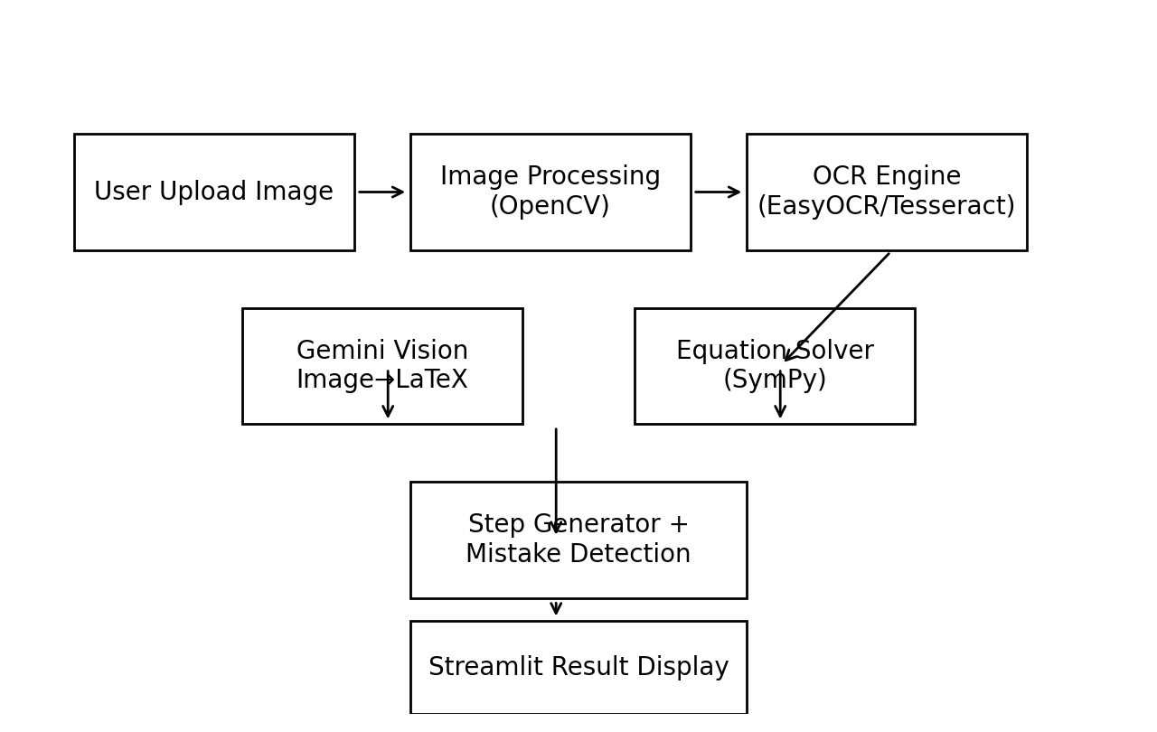

WORKFLOW SCREENSHOT

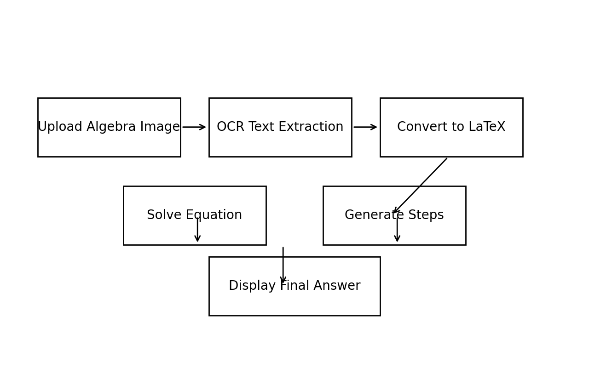

USER INTERFACE SCREENSHOT

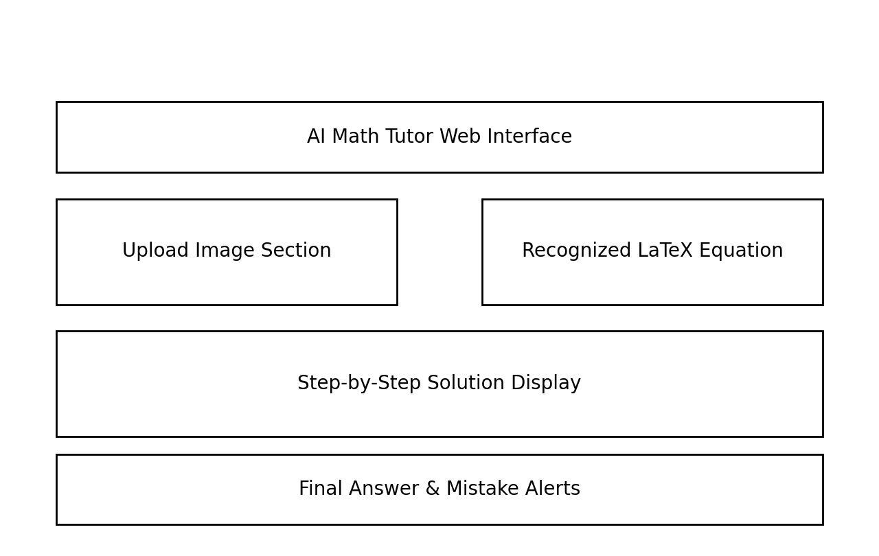

EQUATION SOLVER SCREENSHOT

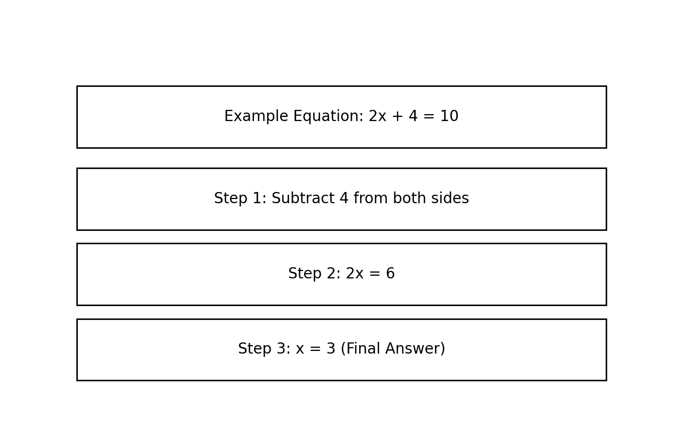
MISTAKE DETECTION SCREENSHOT

